**ELEC 291 Section 20C**

**Project 2 Proposal**

**Due Fri Mar. 18/Mon Mar 21**

**A)** **Group info**

Lab section: L2C Group #: 1 Group’s Lab-Bench #s: 2C and 3C

|  |  |
| --- | --- |
| TEAM MEMBERS | STUDENT NUMBER |
| Pietr Crandall | 46939147 |
| Navjashan Singh | 29695153 |
| Diya Ren | 53483153 |
| Andrew Dombowsky | 31176143 |
| Aaron So | 17150137 |
| Nathalie Janssen | 33377145 |

**B) Project title**: Home Security System with Twitter

**C) Project description and objectives:**

The purpose of this project is implement a simple home security system using an Arduino uno with a bluetooth shield and the internet. This system will be capable of detecting entry to the home and upon doing so will post a photo of the individual entering the home to social media (Twitter). From there we can send a message to the system and inform it whether to sound the alarm or that we have arrived home. We will then add code allowing us to arm the system remotely as well as deactivate it remotely. A keypad will also be added so that the system can be enabled and disabled locally.

Our project consists of many components of which we’ve worked with before so initially as a group the main goal will be to get ourselves comfortable working with the new components (bluetooth shield and camera) and their functionalities. The main objective of the first week will be for everyone to learn how their respective components interacts with the arduino and the system as a whole. For the second week, we will split ourselves into smaller teams to finalize components and make sure everything works as a separate module. The final stretch will consists of integrating all components together one by one and making sure they work along the way. At this point we will be debugging, creating our model and planning the demo. It is expected that this final portion of our project will take the most time and effort so we will try our best to get the first parts done as quickly as possible in order to push our timeline forward and give us breathing room.

**D) System diagram**: include a diagram that graphically represents the main components/blocks in the project and the interactions among them.

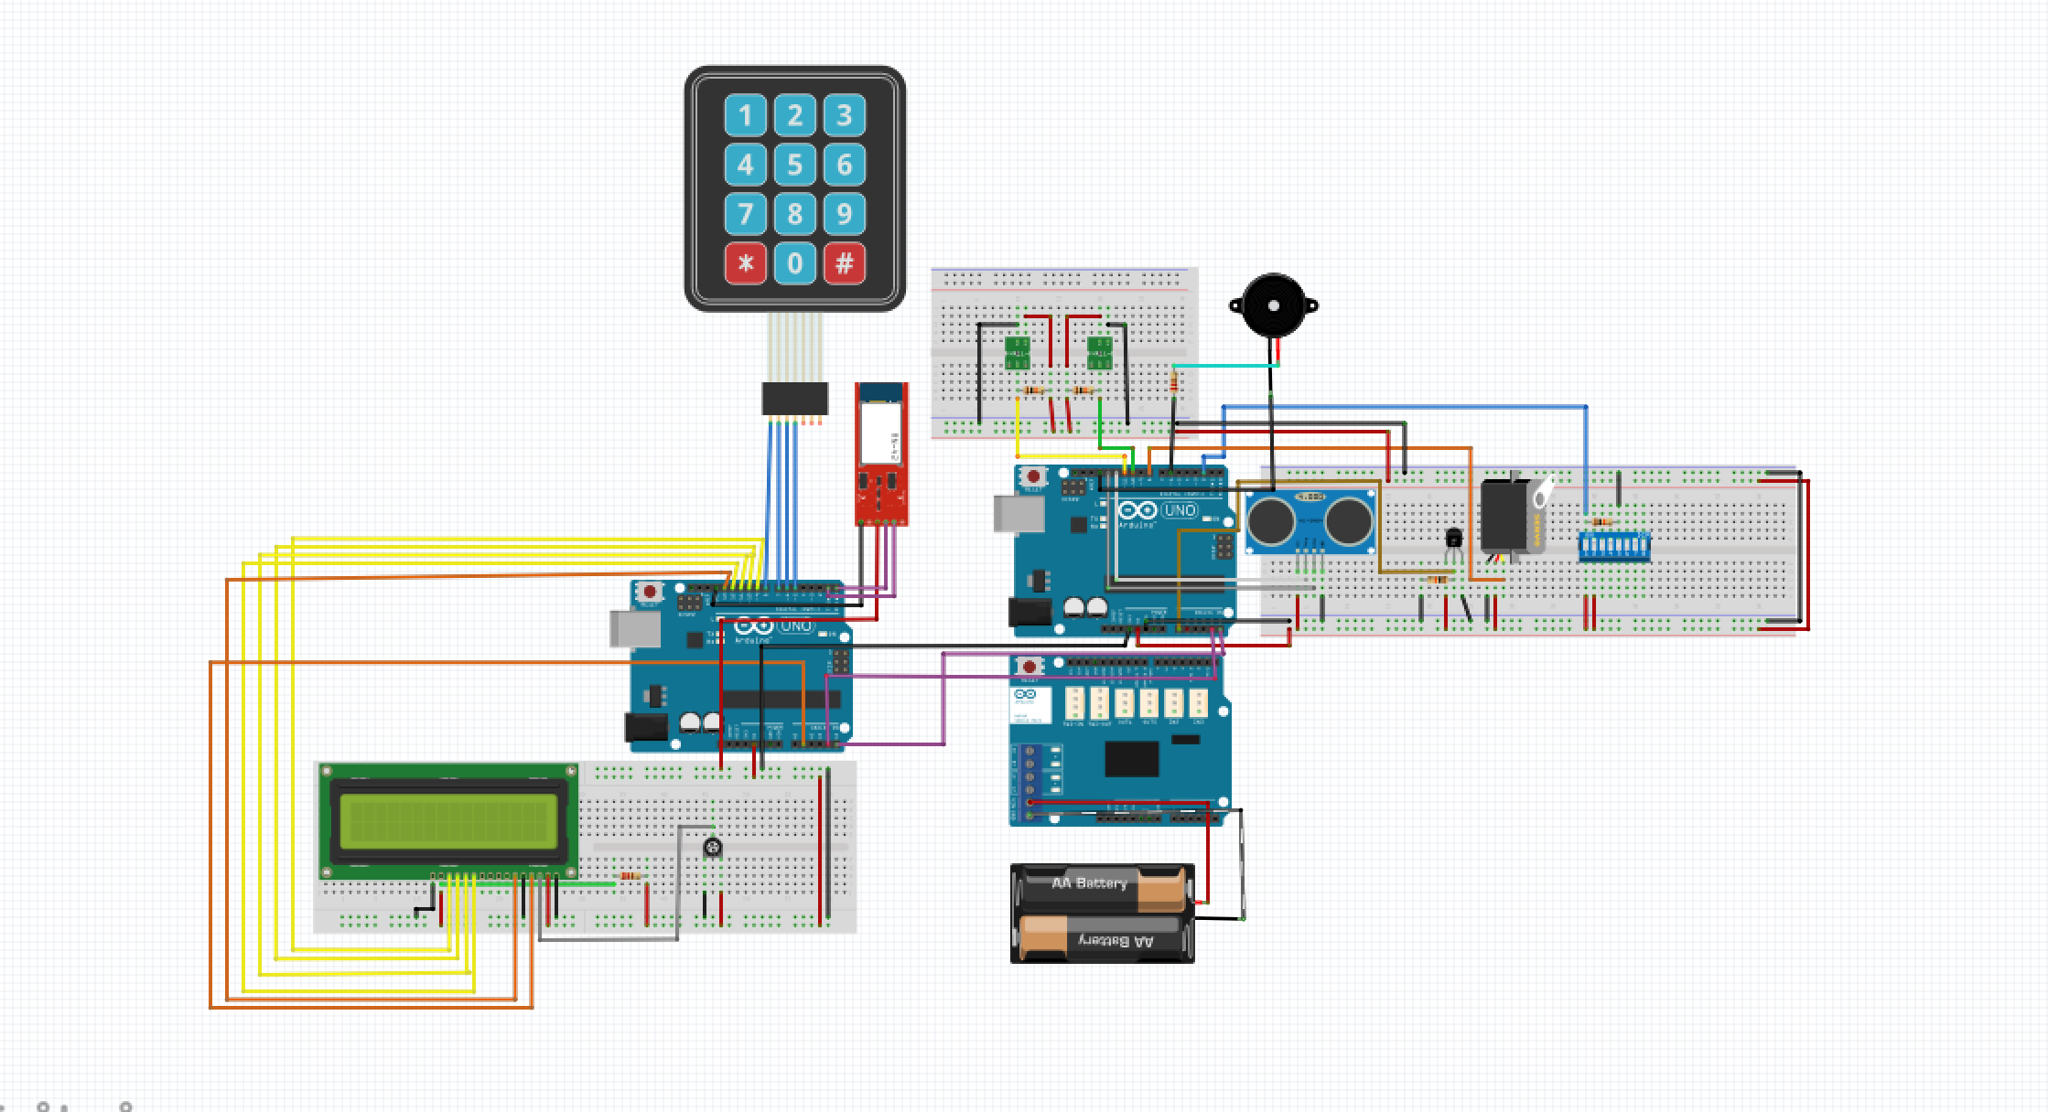

**E) Components**:

**Keypad**: In this project, we will use keypad to activate and deactivate the security system. If someone wants to get in the house without triggering the alarm, he must enter the password correctly. If someone enters the house without entering the correct password, the alarm would be triggered and the alarm would keep going off until someone enters the password to deactivate the security system.

**LCD**: In this project, the usage of LCD will be really simply. In the first case, when someone want to get in the room, the screen will prompt the person to enter the password. After entering the password, the screen will show the password match result on the screen to show whether the password the person entered is right or wrong. If wrong, it will prompt the person to enter password again, if the password is correct, it will signal the door signal the door sensor to open the door to let the people get in. The second case that we will use LCD is, when someone try to get in the word without entering password, the alarm will be triggered and the LCD will show the triggered room(area) information on the screen in order to make us easily to know and detect the problem.

**Buzzer**: Buzzer will be used when the alarm is triggered. After the security system is triggered, it will keep going off until the system is deactivated.

**Hall Effect Sensor:** A hall effect sensor will be used to detect when a door is opened. If the system is activated, it would trigger the alarm to sound. An additional function that we will add if we have the time, is to stop a person from activating the security system and return an error message, if a door is detected to be open at the time of activation.

**Range Finder Sensor:** A range finder sensor will be used as a motion detector. It will trigger the alarm if it senses an object pass through its line of sight (measures a shorter distance) while the system is activated.

**LED:** LED will flash when the alarm is triggered and will continue flashing until system is deactivated.

**BlueSMiRF Silver: (Cost: $31.80 at RP Electronics)** the latest Bluetooth wireless serial cable will be used in combination with the Arduino Uno to add the capability to remotely and wirelessly transmit data to twitter.

**Camera: (Cost: $42.20 at RP Electronics)** A camera will be used to take pictures if the alarm is triggered and send these pictures to the owner. The owner can then choose to deactivate the alarm remotely, if they determine that the pictures don’t show an unwanted intruder.

**F) Timeline**: Include a Gantt chart outlining a preliminary timeline for the project.

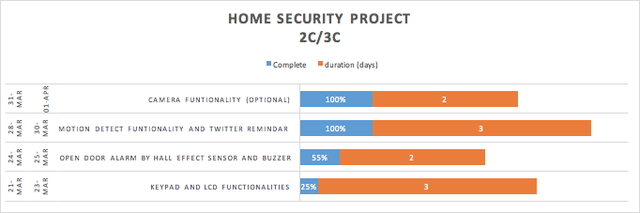

**G) Contributions**:

Circuitry (Hardware): Pietr

Keypad functionality: Andrew

LCD functionality: Diya

Buzzer (Alarm) functionality: Andrew

Hall-effect functionality: Navjashan, Aaron

Range sensor functionality: Nathalie

Camera functionality: Aaron, Andrew

Twitter (remote activation/deactivation): Nathalie

Arduino (integration of system): Pietr, Diya

Building model: Navjashan, (whoever else finishes early)

Report: whole group